

FlatWare
3Dfx Interactive Sprite Library

Revision 1.0
August 29, 1995

3Dfx Interactive, Inc.
415 Clyde Ave., Suite 105
Mountain View, CA 94043
Phone: (415) 934-2400
Fax: (415) 934-2424

1. Introduction
1.1 Purpose
1.2 Integration
1.3 “Is this a 2D game package or a 3D support package?”
2. FlatWare System Design
3. FlatWare Data Structures
3.1 Individual Objects
3.1.1 FwSprite
3.1.2 FwImage
3.1.3 FwTile
3.2 Object lists
3.2.1 FwSpriteList
3.2.2 FwSpriteListNode
4. FlatWare Functions
4.1 Rendering Functions
4.1.1 FwRenderSpriteList
4.1.2 FwRenderSprite
4.1.3 FwRenderTile
4.2 Support Functions
4.2.1 FwLoadImage
4.2.2 FwDownloadImage
5. FlatWare Programmer’s Guide
6. FlatWare Collision Detection Features

Introduction

Purpose
The 3Dfx FlatWare library is a collection of routines which provide a high-level interface for developing sophisticated sprite-based applications, as well as 2D support for 3D applications. The package is a set of C-callable routines packaged with complete source code, programming examples, and documentation.

Integration
The FlatWare library is a collection of Glide utility functions which depend upon the Glide library for operation. This allows programs written using Glide to use FlatWare, mixing sprite objects with 3D objects in the same scene. The difference between a normal Glide program and a Glide program using FlatWare is minimal, the only additional work being the setup of the sprite elements in the scene and a call to a FlatWare function to render the sprite elements. Glide handles such issues as screen resolution, chipset initialization, Y origin, and other common concerns. The GCI library is used as a control interface with FlatWare, just as with other Glide programs.

“Is this a 2D game package or a 3D support package?”
FlatWare serves two very different purposes. Some people will be interested in using FlatWare for creating entire sprite games from scratch. Others will only be interested in using it because it will allow them to easily add 2D objects to their 3D games. It is for this reason that FlatWare is divided into two distinct parts, the rendering support and the collision support. Developers interested in getting a quick start with FlatWare so that they can include 2D objects in their 3D programs with less trouble can simply skip the collision detection portions and not worry about them. Most of the example code is geared toward rendering. Developers interested in using FlatWare for writing an entire sprite-based game will be interested in the collision detection support, which is largely isolated from the rendering issues.

FlatWare System Design
FlatWare provides a simple, easy to understand interface which is intended to allow programmers to concentrate more on the higher-level aspects of application development. The mechanics of clearing the screen, drawing sprites, testing for collisions, moving sprites, rotating and scaling sprites, blending sprites, blending in fog, projecting images onto sprites, and other necessities are handled entirely by the library. The library also intelligently handles issues of optimization, such as 2D clipping of hidden sprites. The programmer’s role moves from that of a stagehand, moving backdrops around a scene, to that of a director, ordering backdrops to be moved around the screen.

When using FlatWare, every frame is drawn from a list of visible sprites. The list contains a description of the sprite, which includes elements such as the sprite’s position, its current scale factor, its current angle of rotation, its chromakey color, whether or not it should be evaluated for collisions with other sprites, and other information which is specific to some of the special effects which FlatWare supports. Once this list is built, a single function call will render the entire scene described by that list. In order to render the next frame, the list is simply modified (not rebuilt, unless a drastic scene change has just happened) and the function is called again.

Figure 1 illustrates the display list concept. The simple scene shown is described by a series of sprite structures which define the way the sprite is displayed. Any number of these objects can be placed in a display list. The scene can be rendered repeatedly by simply calling the refresh function over and over. The scene can then be modified in place and re-rendered with very few memory operations. Sprites can be moved around, rotated, scaled, and otherwise manipulated by simply modifying the display list and calling the refresh function.

Each sprite structure in the display list contains the following information:
- A pointer to an image. This image is in a special format, which is discussed later, in the FxImage section.
- X position, specified in screen coordinates. The X origin is the left-hand side of the screen, and negative coordinates are allowed. X position is specified as a 32-bit floating-point value.
- Y position, specified in screen coordinates. The Y origin is determined by the Y origin flag passed to the function grSstOpen, and negative coordinates are allowed. Y position is specified as a 32-bit floating-point value.
- Scale factor: The scale factor specifies how large the sprite should be on screen. A scale factor of 1.0 indicates that the sprite should be drawn unscaled, with exactly one pixel corresponding to exactly one texel. A scale factor of less than 1.0 indicates that the sprite should be scaled smaller, and a scale factor of more than 1.0 indicates that the sprite should be scaled larger.
- Angle: The angle specifies how far the sprite is to be rotated in screen space. The angle is specified in radians, with 0 being upright, (π/2) being rotated 90 degrees to the right, etc. It is important to note that bilinear filtering eliminates most of the aliasing artifacts that would normally be caused by sprite rotation.
- Chromakey: The chromakey value specifies the color which is transparent for the sprite. If a rectangular sprite is actually desired, the chromakey option can be disabled, using a separate flag on a per-sprite basis.
- Depth: The depth value represents the relative depth of the sprite, either in terms of z or in terms of w. This feature can be used to arrange the sprites in space such that some sprites are “behind” others and are thus not visible when blocked.
In addition to the above information, each sprite will also contain information on whether or not and how to blend the sprite with other sprites in the scene, and other information. The sprite structure is described in more detail later.

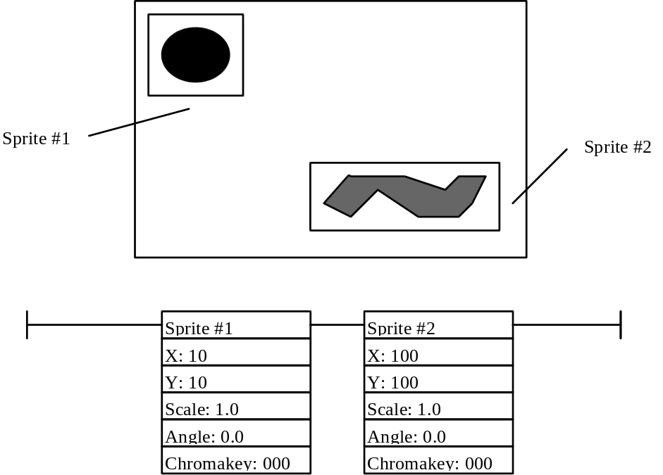
Figure 1: A simple sprite scene and its associated sprite list.

FlatWare Data Structures
The FlatWare utility functions make extensive use of two data structures, a sprite list structure and a sprite object structure. The sprite list structure, which is an invocation of the FwSpriteList structure, defines a list of sprites to be rendered, in terms of pointers to many individual FwSprite structures. Each FwSprite contains the information that describes a sprite’s unique position and representation on screen, whereas a FwSpriteList is simply a collection of objects which is used to communicate to the rendering function.

Individual Objects

FwSprite
As described earlier, a FwSprite structure contains the following information:
Name | Type | Description
Image | (FwImage *) | A pointer to an image to be drawn for this sprite.
XPosition | float | The X position of the center of the sprite on screen.
YPosition | float | The Y position of the center of the sprite on screen, modified by the current Y origin state.
Scale | float | The scaling of the sprite from its normal size. By default (Scale==1.0), a sprite is rendered such that one texel of the largest MIP map level corresponds in size with one pixel in screen space. A scale factor of 0.5 would generate a sprite which is half as large in screen space, and 2.0 would generate a sprite which is twice as large.
Angle | float | The angle by which a sprite is rotated when it is displayed. The angle is represented in radians, with Angle==0 representing a sprite which is not rotated at all, Angle==(π/2) representing a sprite which is rotated 90 degrees to the right, Angle==π representing a sprite which is upside-down, etc.
Mirror | FxBool | A flag which indicates whether or not to invert the pre-rotated sprite from left to right. This flag, used in combination with the Angle parameter, can produce vertical mirroring as well. If a sprite is mirrored, the source image is simply drawn backwards. The XPosition and YPosition retain their meaning.
ChromakeyColor | GrColor_t | Specifies which color will be interpreted as the transparent color when the sprite is rendered.
ChromakeyEnable | FxBool | Specifies whether the chromakey function should be enabled. If this flag is true, the specified chromakey color will be transparent, otherwise, it will be rendered normally.
Depth | float | Describes the depth of the sprite for Z-buffering or W-buffering purposes. This value has nothing to do with the size of the sprite on screen, which is entirely determined by the Scale parameter. The Depth value is only relevant in determining which sprites and/or 3D objects occlude which others.
DepthBufferEnable | FxBool | Determines whether or not the sprite will be subject to depth-buffer tests. If depth-buffering is enabled, then FlatWare will enable depth buffer tests using the current conventions used by Glide (either W or Z buffering) in order to determine on a per-pixel basis whether or not to draw the sprite. This will allow sprite objects to act as 2D billboard objects that can interact with a 3D scene and still be properly drawn.
DepthWriteEnable | FxBool | Determines whether or not the sprite will leave evidence of its existence in the depth buffer. It is possible to test against the depth buffer for visibility, but not modify the depth buffer, no matter what the test determines.
CollisionMode | FwCollision | Specifies the way in which this sprite takes advantage of FlatWare’s collision detection functionality. It is simple to set up this structure such that no collision detection is performed.

FwImage
An FwImage structure is a way of specifying the source image which is displayed when a sprite is drawn. Optimally, this would be as simple as a width value, a height value, and a pointer to a linear stream of data in memory, but because of certain minor inconveniences related to restrictions imposed by the SST graphics subsystem, it is a little more difficult to define an image. Although the SST graphics subsystem cannot operate using textures larger than 256 by 256 texels, FlatWare operates in terms of images which can be of any size. These images are handled transparently to the programmer. The programmer simply uses the FwImage utility to create a disk-writable version of the FwImage structure from an image file, and FlatWare handles the organization of the image into 256 by 256 texel tiles. In general, it should not be necessary to manually create an FwImage structure, but the structure is documented here anyway.
Name | Type | Description
TilesWide | FxU32 | The width, in 256 by 256 tiles, of the total image.
TilesHigh | FxU32 | The height, in 256 by 256 tiles, of the total image.
PixelXOrigin | float | The x coordinate upper-left-hand corner of the beginning of the image, in terms of an offset from the upper-left-hand corner of the upper-left-hand tile.
PixelYOrigin | float | The y coordinate upper-left-hand corner of the beginning of the image, in terms of an offset from the upper-left-hand corner of the upper-left-hand tile.
PixelWidth | float | The width of the image, in pixels.
PixelHeight | float | The height of the image, in pixels.
TileList | (FwTile *) | A pointer to a linear sequence of tiles which contain the image data.

The following diagram illustrates the FwImage structure, the six solid boxes represent the 256 by 256 texel tiles that make up the sprite. The dotted line represents the actual sprite which is intended to be represented on screen. The TilesWide element of his particular FwImage would be 3, the TilesHigh element would be 2. The PixelXOrigin and PixelYOrigin would point to the upper-left-hand corner of the dotted box, and the PixelWidth and PixelHeight would indicate the width and height of the dotted box. The FwTile structure would point to a linked list containing the six tiles, first the top row, then the bottom row. It is a pointer to this entire structure that is contained in an FwSprite structure.

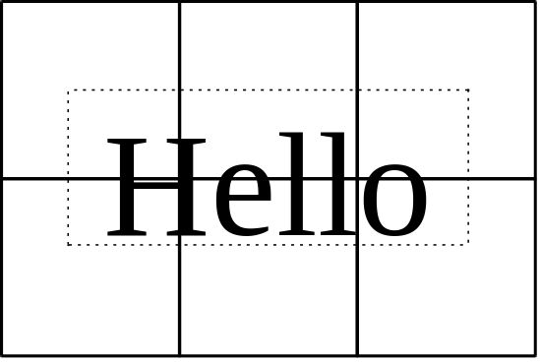
Figure 2: A FlatWare image structure, divided into 256 by 256 tiles.

FwTile
The FwTile object contains very little information. It is simply a pointer to a texture in memory for use as the source image for the current tile, and a pointer to the next tile. It exists so that linked lists of tiles can be formed in FwImage structures.
Name | Type | Description
Texture | Gu3dfInfo | A pointer to the image information which has been read from a file.
TextureID | GrMipMapId_t | An indicator of the position of the MIP map in the SST graphics subsystem’s local memory. If the FwImage structure that this tile is a part of has been read from a disk but not yet downloaded to the hardware, this field will be NULL. Once the FwImage is downloaded to the hardware, this field will be filled in.
Next | FwTile | A pointer to the next tile in the list. NULL, if this is the last.

Object lists
The preceding data structures are fundamental to the creation of a single sprite object. The individual sprite objects are not very useful without a mechanism for tying them together. The following data structures are used for creating entire sprite scenes by linking together several individual sprite objects.

FwSpriteList
An FwSpriteList is simply a linked list which serves as an abstract way to collect together many different FwSprite structures into a scene. If FlatWare is being used for support of a 3D game, it is possible that several different FwSpriteList structures may be used in a single frame. An FwSpriteList is the variable which is passed to the FwRenderSpriteList function. It contains only one element.
Name | Type |  | Description
Nodes |  | FwSpriteListNode | A pointer to the first FwSpriteListNode object in the sprite list. NULL, if there are none.

FwSpriteListNode
A sprite list node is a single entry in the linked list which makes up a sprite list. It is equally simple.
Name | Type |  | Description
Object |  | FwSprite | A pointer to a sprite object.
Next |  | FwSpriteListNode | A pointer to the next node, NULL if this is the last.

FlatWare Functions
The FlatWare functions are broken up into two groups, functions that produce output, and functions which provide support to those functions which produce output.

Rendering Functions
These functions are the heart of FlatWare. The first is used to render a list of sprites on screen, and the second is used to render a single sprite. The function FwRenderSpriteList actually uses the second function repeatedly, which in turn calls FwRenderTile. The function FwRenderTile was not intended to be used by application programmers, but it is documented for completeness.

FwRenderSpriteList
Name
FwRenderSpriteList -- Render an entire list of sprites with one function call.
C Specification
void FwRenderSpriteList( FwSpriteList List )
Parameters
List The list of sprites to be rendered.
Description
FwRenderSpriteList saves the state of Glide and renders an entire list of sprites. It is the preferred interface function for FlatWare, especially in cases where FlatWare is being used to add sprite objects to a 3D scene, since all of the 2D rendering is automatically isolated from the 3D rendering, and the current Glide state is saved automatically.

FwRenderSprite
Name
FwRenderSprite -- Render a single sprite.
C Specification
void FwRenderSprite( FwSprite Sprite )
Parameters
Sprite The sprite to be rendered.
Description
FwRenderSprite does not save the state of Glide. It simply renders a single sprite, handling the sprite attributes and the assembly of the sprite from its component tiles.

FwRenderTile
Name
FwRenderTile -- Render a single tile of a sprite.
C Specification
void FwRenderTile( FwTile Tile )
Parameters
Tile The tile to be rendered.
Description
FwRenderTile does not save the state of Glide. It simply renders a single tile.

Support Functions
These two functions provide sprite-level support for reading image information from disk and then downloading it to the SST graphics subsystem. This operation is divided into two parts so that a sprite can be loaded from disk into memory and stored there until it is needed.

FwLoadImage
Name
FwLoadImage -- Load a sprite image from an spr file into memory.
C Specification
FwImage FwLoadImage( char *Filename )
Parameters
Filename The name of the file to be read.
Description
Reads in a complete image from disk, including all of its component tiles. The image must first be read into memory with this function before it can be downloaded to the hardware with FwDownloadImage.

FwDownloadImage
Name
FwDownloadImage -- Download a sprite from memory to the SST graphics subsystem
C Specification
FxBool FwLoadImage( FwImage Image)
Parameters
Image The image to be downloaded.
Description
Downloads an entire image to the hardware and fills in the TextureID field of each tile in the image. This function cannot be used until an FwImage structure has either been loaded with FwLoadImage or created manually. If an image is being downloaded for the second or later time, FwDownloadImage will overwrite the TextureID values that are already present and attempt to download the image again.

FlatWare Programmer’s Guide
In order to use FlatWare the way in which it was intended, a program must first prepare a list of sprites to be drawn and present them to FlatWare ready to go. This section provides an explanation of that process.
* Author’s note: This section will evolve as I write the code for FlatWare. It is difficult to write a guide on how to write a FlatWare program without ever having written a FlatWare program. This section will contain a simple example program which has been dissected.

FlatWare Collision Detection Features
This section is not quite cooked yet.
* Author’s note: This section will be worked out once the rendering code is working properly.

